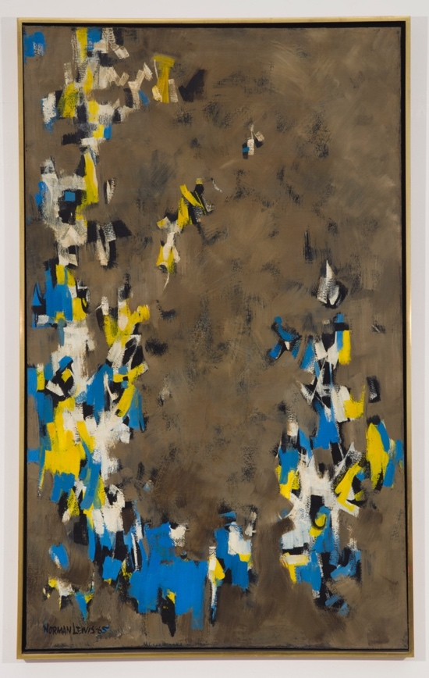
Beyond the Spiral
October 28 through December 22, 2023
ACA Galleries
173 Tenth Avenue, New York

New York, NY… ACA Galleries is pleased to present “Beyond the Spiral,” an exhibition featuring artists from the legendary Spiral Group and the ways their artwork and production were influenced by their brief association. This exhibition is the second show held in the gallery’s new second location at 173 Tenth Avenue (20th Street) in Chelsea.

Active from 1963 to 1965, The Spiral Group was a New York–based African American artists’ collective founded by Charles Alston, Romare Bearden, Norman Lewis, and Hale Woodruff who proposed the name. The Archimedean Spiral is an inclusive circular form which moves outward and upward. It symbolized the group’s common goals to further advance their careers and contribute to the Civil Rights Movement while retaining their artistic individuality.
Norman Lewis, Untitled, 1965
oil on canvas, 63 x 37 1/8 inches

The group met weekly to discuss their experiences and relationships between art and activism, and included prominent artists such as Emma Amos, Ernie Crichlow, Calvin Douglass, Perry Ferguson, Reginald Gammon, Felrath Hines, Alvin Hollingsworth, William Majors, Richard Mayhew, Earl Miller, Merton D. Simpson, James Yeargans among others.
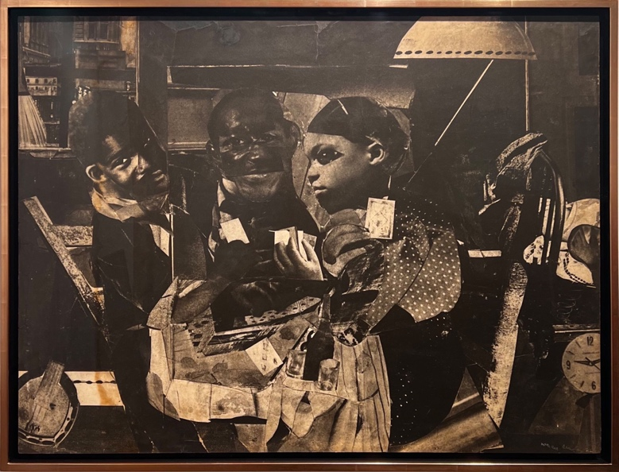
Romare Bearden, Evening 9:30, 461 Lenox Ave, 1964 photomontage projection, 29 x 38 inches
ACA Galleries has had long associations with several Spiral Artists including Ernie Crichlow who the gallery began exhibiting in the 1940s; Romare Bearden, whose estate was represented from 1988 - 2000 and Richard Mayhew from 1996 to the present.

This exhibition spotlights a group of important collages by Romare Bearden and several major paintings by Richard Mayhew, alongside a rare Norman Lewis painting from 1965, collages by William Majors, a painted fiber tapestry by Emma Amos and paintings and drawings by Ernest Crichlow and others.

ABOUT ACA GALLERIES
The American Contemporary Art Gallery (ACA) was established in 1932 by Herman Baron; the founding charter members included modernist painters Stuart Davis and Yasuo Kuniyoshi. At that time ACA was one of only three galleries in New York dedicated to exhibiting American art. Over the decades the gallery’s breadth and scope has expanded and now includes 19th century, Modern and Contemporary American painting, sculpture and photography.

Throughout the gallery’s history ACA has presented over 800 exhibitions and published over 400 books and catalogues. The gallery also organizes traveling museum exhibitions nationally and abroad. For over 90 years ACA Galleries has served as an advisor to important museums, institutions and private collectors.

ACA’s pioneering interest in progressive American art was established early on in exhibitions featuring, and often introducing, the work of Rockwell Kent, Alice Neel, Barnett Newman, Irene Rice Pereira, David Smith, and Charles White, among a myriad of others. In 1935, ACA hosted the inaugural meetings of the American Artists’ Congress (AAC), the influential precursor to the Federal Art Project (FAP) and Works Project Administration (WPA), federal programs that aided American artists and funded public art projects throughout the depression.

Today, the gallery has expanded to a second gallery space in the Chelsea arts district of New York City located at 173 Tenth Avenue. The expansion is the evolution of ACA’s central mission: to honor the gallery’s deep historical roots by reimagining them in a contemporary context. The gallery continues to break new ground, representing distinguished artists and estates, and presenting several exhibitions per year. The artistic and humanitarian mission of the gallery still endures, and ACA is committed to upholding this tradition by continuing to support artists united in their commitment to make significant and brave contributions to the field.

###
For Press Inquiries, please contact:
Alix Dana: alix@danamannix.com

For Artwork Inquiries, please contact:
Mikaela Sardo Lamarche: curator@acagalleries.com | +1-212-206-8080

